**Pentacam HR**

LASIK (Laser Assisted In Situ Keratomileusis) surgery and excimer laser Photorefractive Keretectomy (PRK) are the most common vision correction procedures across the world for the treatment of refractive errors in the eyes. LASIK helps in the treatment of a wide range of refractive errors such as Myopia (nearsightedness), hypermetropia (farsightedness) and astigmatism.

At H.V. Desai Eye Hospital, we believe in helping people get rid of their glasses and educating them about LASIK surgery. For those who are found to be unfit for LASIK, we provide PRK.  
The availability of the latest technologically advanced diagnostic equipment and laser technology has enabled us to provide better, safer and predictable outcomes. Wavefront-guided LASIK is among the most preferred methods for vision correction worldwide. With its excellent safety profile, patient comfort and superior visual outcomes, wavefront-guided laser platforms provide the best image quality with a clearer vision. The entire vision correction procedure takes less than 15 minutes, and patients are able to resume their day-to-day activities the very next day.  
H.V. DESAI Eye Hospital is equipped with the best diagnostics equipment such as the pentacamHR, corneal wavefront analyser -Keratron scout and ORK wavefront analyser.

**Schwind Combi Wavefront Analyser**

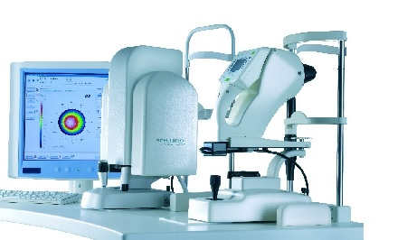

H.V. Desai Eye Hospital offers customised solutions for laser surgeries, which include Corneal Wavefront Optimised Lasik Laser Surgery, Wavefront-Guided Lasik Laser Surgery, Phototherapeutic Keratectomy and Topoguided Laser Treatments for Keratoconus. The head of department Dr. Mukesh Paryani is an experienced LASIK surgeon trained at Bangalore . He has a vast experience of performing LASIK surgeries over different laser platforms.

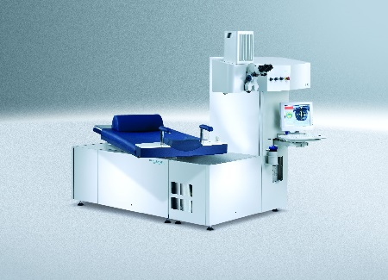

With the availability of experienced surgeons and the best technologies at an affordable cost enables our patients to gain superior spectacle-free vision. For any LASIK-related queries and for fixing an appointment for consultation, contact H.V. Desai Hospital at: